**PREREQUISITES**

|  |  |
| --- | --- |
| DATE | 29 October 2022 |
| TEAM ID | PNT2022TMID34135 |
| PROJECT NAME | IoT based smart crop protection system for agriculture |
| MAXIMUM MARKS | 8 Marks |

**Creation of IBM cloud account:**

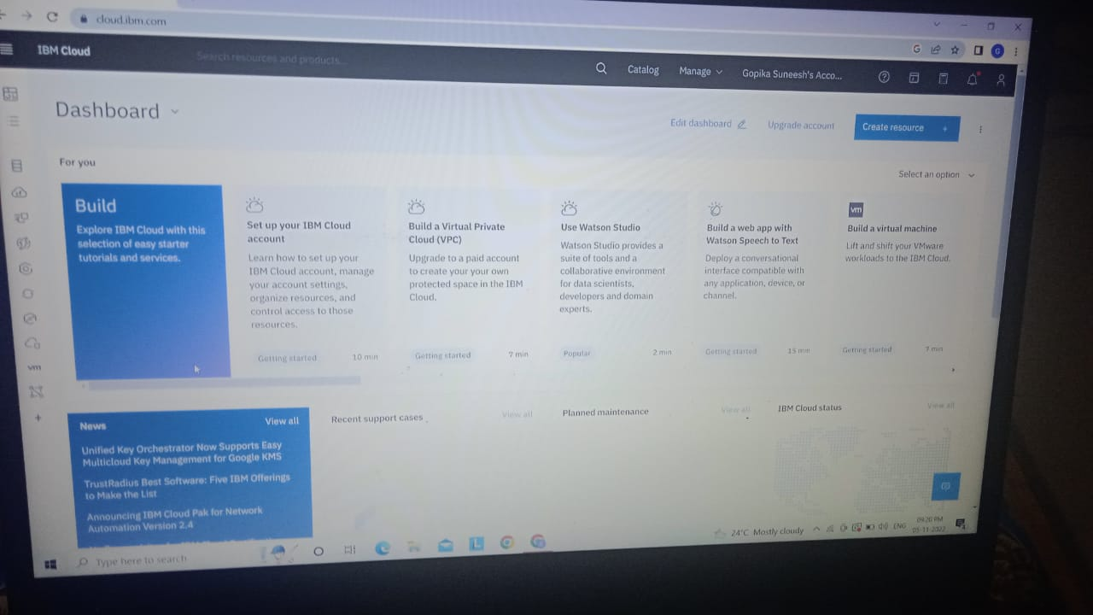

**Python Installation:**

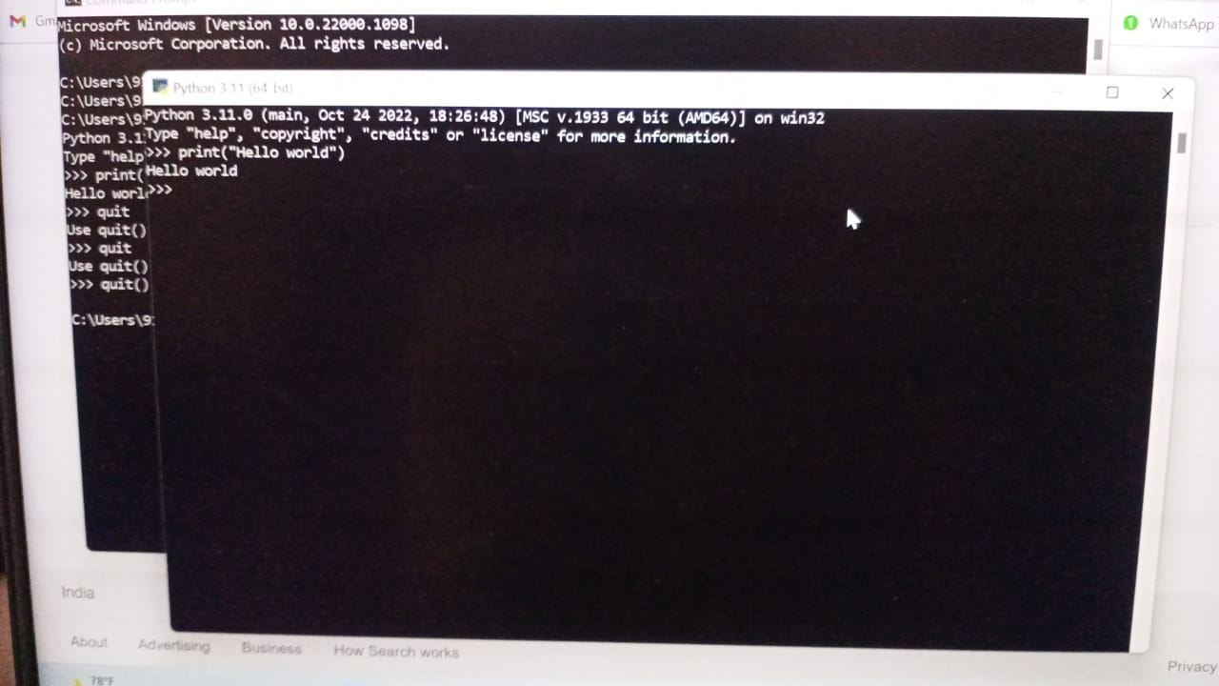

**Creation of account in Clarifal:**

